Software Requirements Specification (SRS) Report
Project Title: Quiz Application
Supervision: Miss Muniba Memon
Department: Artificial Intelligence
Team Members: 23BSAI-15 Irfan Ali
23BSAI-37 Sikander Ali
233BSAI-51 Talat Abass

- Introduction

Our Project is a Quiz Application developed in Java, designed to provide an interactive and engaging way to test knowledge on various topics.

- Scope Of Quiz Application

- The primary objective of the Quiz Application is to create an engaging and educational tool that allows users to take quizzes on different topics, track their progress, and improve their knowledge.

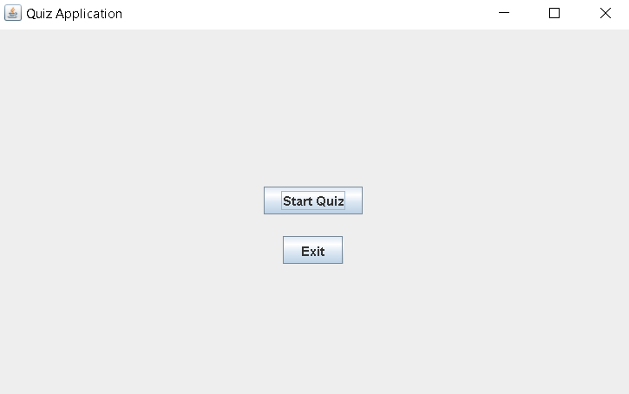
- Features

The application includes the following features:
- User login
- Multiple-choice questions with varying difficulty levels
- Score tracking
- Timer for each quiz
- Result analysis and feedback

- Activity Diagram

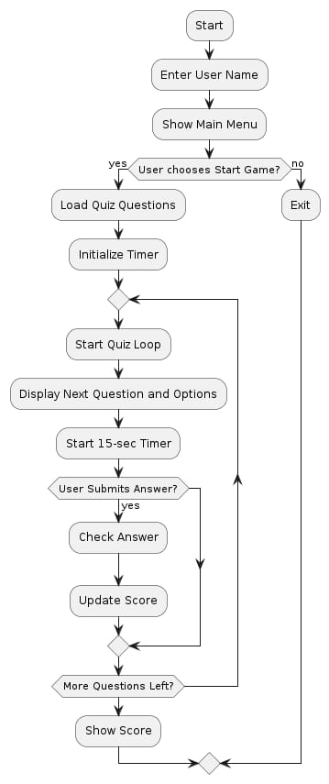

- Class Diagram

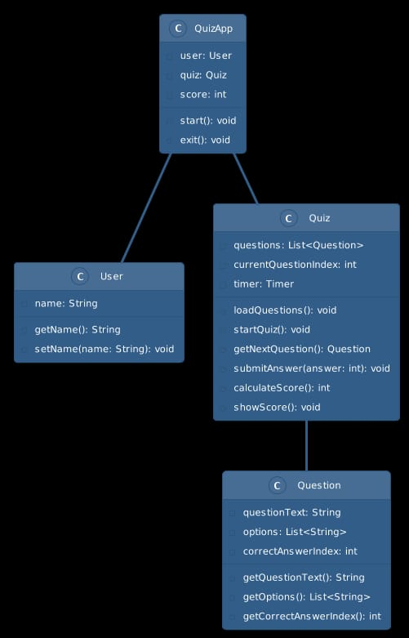
- Use Case Diagram

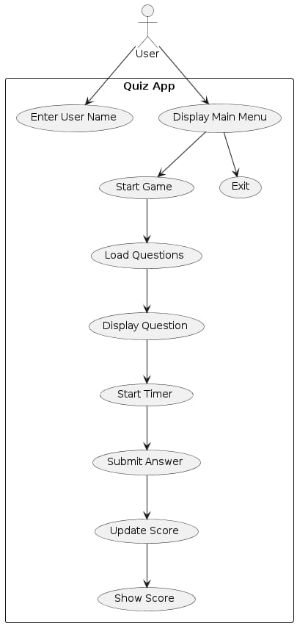

- Conclusion

The Java-based Quiz Application provides an engaging platform for users to test their knowledge with multiple-choice quizzes. Key features include user registration, score tracking, and result analysis. While the current version supports only single-user mode and requires a local database, future updates will address these limitations and enhance functionality. Overall, the application is a valuable educational tool with potential for growth.

